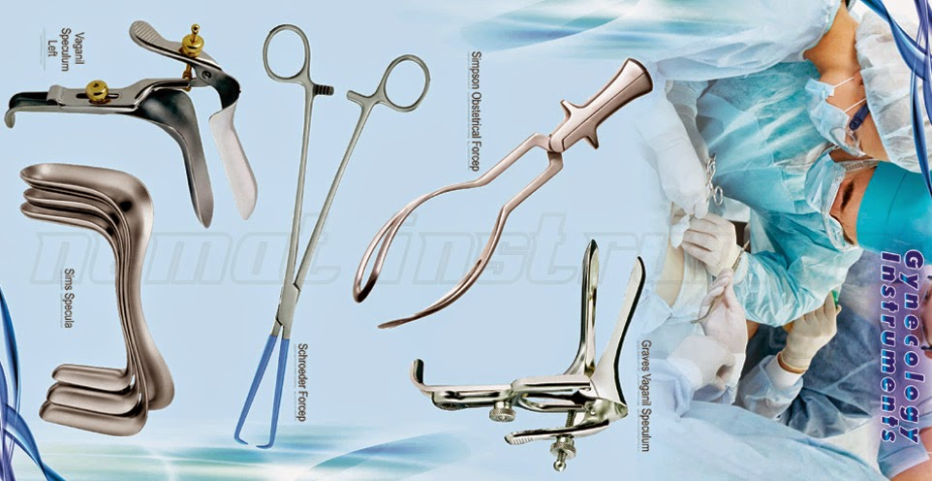
NORTH INDIA SURGICALS
GYNAECOLOGY & OBSTRATRIC INSTRUMENTS

H.O.- Block- A - 161/1, Majlis Park, Adarsh Nagar Delhi – 110033
B.O.- Shop No. 51,L.S.C.DDA,Mkt.Pkt-B,Phase-III,AshokVihar,Delhi-110052
Mobile:- 9810348909 / 9818899350 – email:-northindiasurgicals@gmail.com

